1. Menulis ulang kode program

Menambang semua frequent itemset tanpa parameter *minlen* dan *maxlen*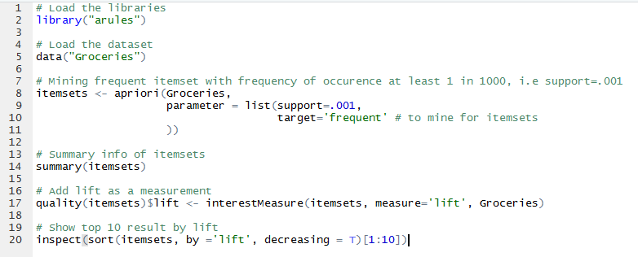Line 2: Menggunakan library arules

Line 4: Menggunakan dataset Groceries

Line 8: Mining itemset paling sering dengan jumlah kejadian paling sedikit 1 dalam 1000 dengan support =.001

Line 14: Membuat kesimpulan informasi itemsets

Hasil line 14:

most frequent items:

whole milk other vegetables yogurt root vegetables

3765 3342 2402 1959

tropical fruit (Other)

1797 27835

Line 17: Menambahkan lift sebagai pengukur

Line 20: Menampilkan 10 hasil paling atas diurutkan berdasarkan lift

Hasil line 20:

items support count lift

[1] {tropical fruit,

root vegetables,

other vegetables,

whole milk,

yogurt,

oil} 0.001016777 10 459.3068

[2] {tropical fruit,

other vegetables,

whole milk,

butter,

yogurt,

domestic eggs} 0.001016777 10 399.6002

[3] {tropical fruit,

root vegetables,

other vegetables,

whole milk,

butter,

yogurt} 0.001118454 11 255.8634

[4] {other vegetables,

curd,

yogurt,

whipped/sour cream,

cream cheese } 0.001016777 10 248.7251

[5] {root vegetables,

other vegetables,

whole milk,

yogurt,

rice} 0.001321810 13 230.5682

[6] {citrus fruit,

root vegetables,

other vegetables,

whole milk,

yogurt,

whipped/sour cream} 0.001016777 10 227.9702

[7] {tropical fruit,

pip fruit,

root vegetables,

other vegetables,

whole milk,

yogurt} 0.001321810 13 221.5044

[8] {citrus fruit,

tropical fruit,

root vegetables,

other vegetables,

whole milk,

yogurt} 0.001423488 14 218.0297

[9] {whole milk,

curd,

yogurt,

whipped/sour cream,

cream cheese } 0.001118454 11 207.1851

[10] {beef,

tropical fruit,

root vegetables,

other vegetables,

whole milk,

rolls/buns} 0.001118454 11 204.9606

Menambang semua frequent itemset tanpa parameter *minlen* dan *maxlen (*hanya menampilkan *5 association* mining rule*)*

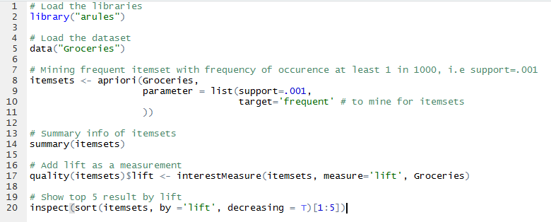

Line 2: Menggunakan library arules

Line 4: Menggunakan dataset Groceries

Line 8: Mining itemset paling sering dengan jumlah kejadian paling sedikit 1 dalam 1000 dengan support =.001

Line 14: Membuat kesimpulan informasi itemsets

Line 17: Menambahkan lift sebagai pengukur

Line 20: Menampilkan 5 hasil paling atas diurutkan berdasarkan lift

Hasil line 20:

items support count lift

[1] {tropical fruit,

root vegetables,

other vegetables,

whole milk,

yogurt,

oil} 0.001016777 10 459.3068

[2] {tropical fruit,

other vegetables,

whole milk,

butter,

yogurt,

domestic eggs} 0.001016777 10 399.6002

[3] {tropical fruit,

root vegetables,

other vegetables,

whole milk,

butter,

yogurt} 0.001118454 11 255.8634

[4] {other vegetables,

curd,

yogurt,

whipped/sour cream,

cream cheese } 0.001016777 10 248.7251

[5] {root vegetables,

other vegetables,

whole milk,

yogurt,

rice} 0.001321810 13 230.5682

Menambang semua frequent rule tanpa parameter *minlen* dan *maxlen*

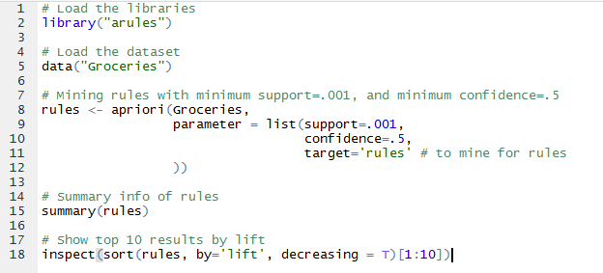

Line 2: Menggunakan library arules

Line 4: Menggunakan dataset Groceries

Line 8-10: *Mining rules* paling dengan minimun support =.001 dan minimum confidence=.5

Line 15: Membuat kesimpulan informasi *rules*

Line 18: Menampilkan 10 hasil paling atas diurutkan berdasarkan *lift* tertinggi

Hasil line 18

[1] {Instant food products,

soda} => {hamburger meat} 0.001220132 0.6315789 18.99565 12

[2] {soda,

popcorn}=> {salty snack} 0.001220132 0.6315789 16.69779 12

[3] {flour,

baking powder}=> {sugar} 0.001016777 0.5555556 16.40807 10

[4] {ham,

processed cheese} => {white bread} 0.001931876 0.6333333 15.04549 19

[5] {whole milk,

Instant food products} => {hamburger meat} 0.001525165 0.5000000 15.03823 15

[6] {other vegetables,

curd,

yogurt,

whipped/sour cream} => {cream cheese } 0.001016777 0.5882353 14.83409 10

[7] {processed cheese,

domestic eggs} => {white bread} 0.001118454 0.5238095 12.44364 11

[8] {tropical fruit,

other vegetables,

yogurt,

white bread} => {butter} 0.001016777 0.6666667 12.03058 10

[9] {hamburger meat,

Yogurt,

whipped/sour cream} => {butter} 0.001016777 0.6250000 11.27867 10

[10] {tropical fruit,

other vegetables,

whole milk,

yogurt,

domestic eggs} => {butter} 0.001016777 0.6250000 11.27867 10

Menambang semua frequent rule tanpa parameter *minlen* dan *maxlen (*hanya menampilkan *5 association* mining rule*)*

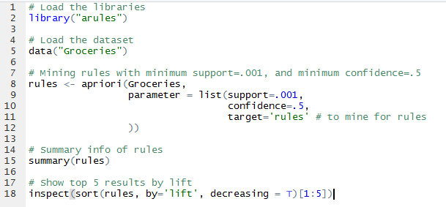

Line 2: Menggunakan library arules

Line 4: Menggunakan dataset Groceries

Line 8-10: *Mining rules* paling dengan minimun support =.001 dan minimum confidence=.5

Line 15: Membuat kesimpulan informasi *rules*

Line 18: Menampilkan 5hasil paling atas diurutkan berdasarkan *lift* tertinggi

Hasil line 18 :

[1] {Instant food products,soda} => {hamburger meat} 0.001220132 0.6315789 18.99565 12

[2] {soda,popcorn} => {salty snack} 0.001220132 0.6315789 16.69779 12

[3] {flour,baking powder} => {sugar} 0.001016777 0.5555556 16.40807 10

[4] {ham,processed cheese} => {white bread} 0.001931876 0.6333333 15.04549 19

[5] {whole milk,Instant food products} => {hamburger meat} 0.001525165 0.5000000 15.03823 15

1. Program mining_rules.R tanpa parameter *minlen* dan *maxlen*, untuk menampilkan 5 *association mining rule* dengan nilai pengukuran ***chiSquared*** tertinggi.

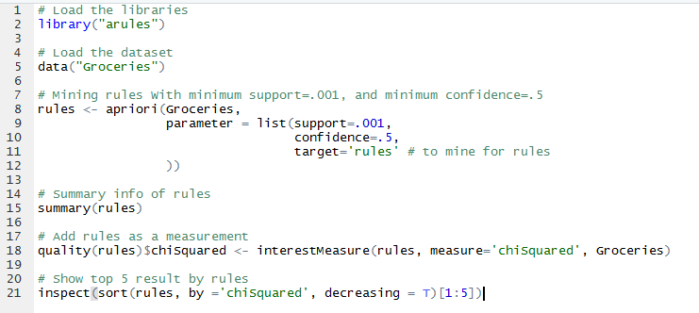

Hasil line 21:

[1] {ham,

processed cheese} => {white bread} 0.001931876 0.6333333 15.045491 19 260.8706

[2] {Instant food products,

soda} => {hamburger meat} 0.001220132 0.6315789 18.995654 12 212.0251

[3] {tropical fruit,

root vegetables} => {other vegetables} 0.012302999 0.5845411 3.020999 121 207.2034

[4] {whole milk,

Instant food products} => {hamburger meat} 0.001525165 0.5000000 15.038226 15 203.9535

[5] {liquor,

red/blush wine} => {bottled beer} 0.001931876 0.9047619 11.235269 19 193.0896